**User Survey Analysis**

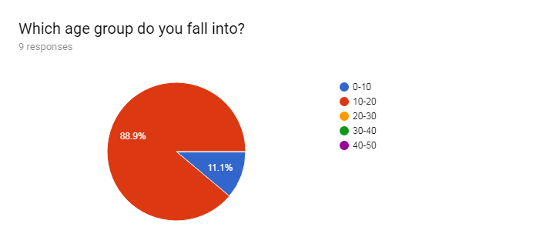

The majority of my users are within the age group of 10-20 year olds, so my website should pertain to them rather than say children or the elderly. This means that text sizes shouldn’t be too small and there should still be enough colour and such to keep users attracted to the website.

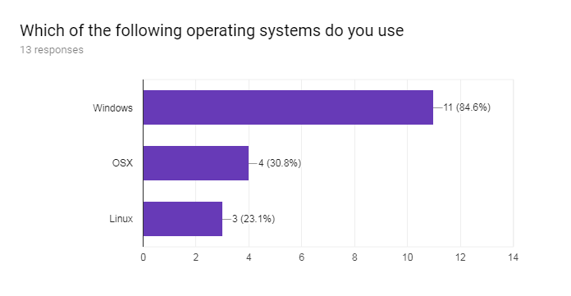

As the majority of my users use the windows operating system I will be building my website for the windows operating system as it pertains to the widest audience. Mac OSX and Linux are somewhat popular but nowhere near the level of Windows.

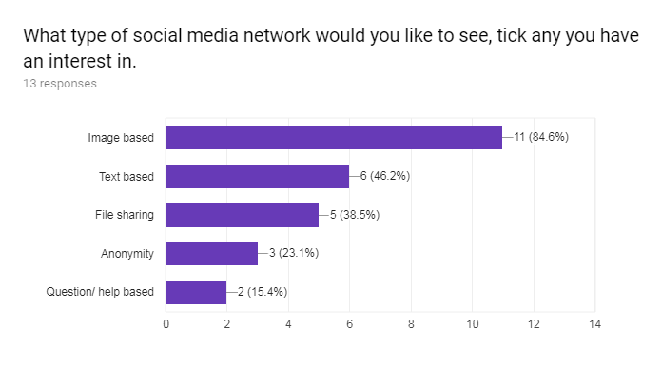

I sadly was not able to implement an image based social media website due to the complexity of data storage and the handling of the image between the html to the server to the sql. The site in the end ended up being text based which is the second highest feature voted for.

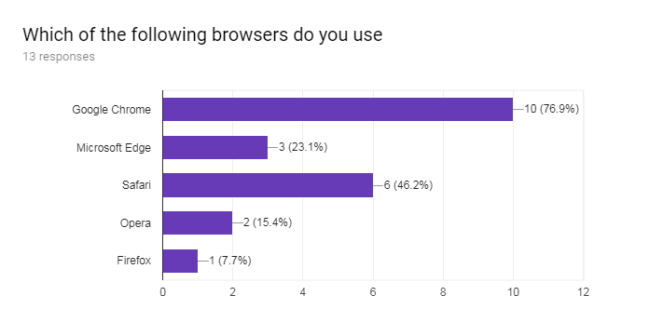

Google Chrome and Safari are the most notable web browsers. However, as I will be developing my website for windows pc's I will be ignoring Safari as Google Chrome is used more on windows computers than Safari is and as such will lead me to have a have a wider pool of potential users.

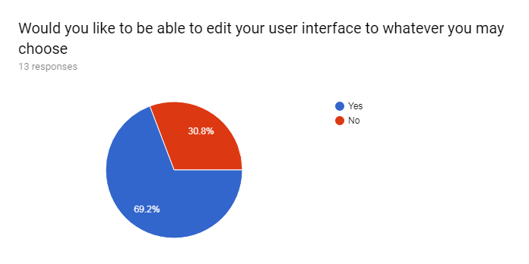

I was not able to implement a day night theme as it would require me to create a new field for users specifying the theme that they would be using and then having to populate that field which, along with creating the javascript which would change each page depending on the theme field in the sql. By the time I had come round to attempting it, I was running out of time to finish my implementation. Leading me to not include this feature.

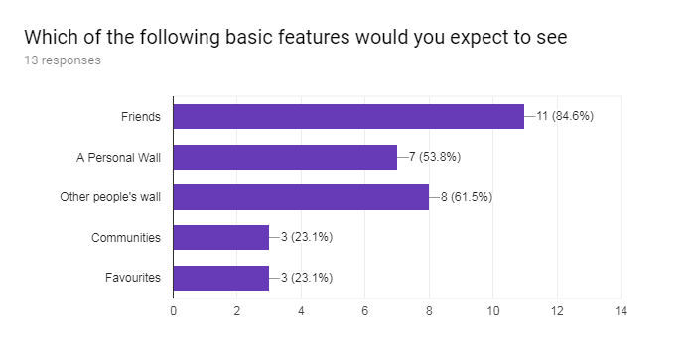

I was not able to implement a friends feature in the time I had left for the implementation due to the difficulty in making it happen. A personal wall and the ability to see other people's wall was implemented. Communities and favourites were ignored

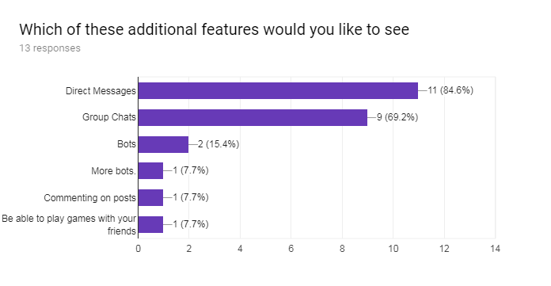

People really want to have direct messages and group chats so I will try and make them available to users. Others were not voted for much only having one or two votes so I am unlikely to be implementing them but will do if there is time.

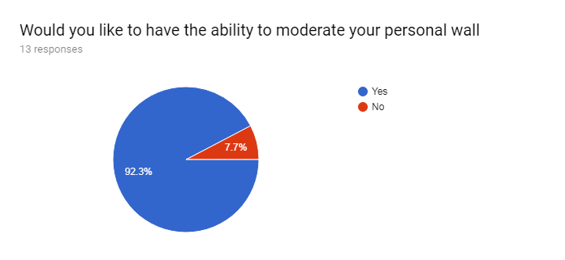

I ended up not being able to implement the feature to allow users to moderate their personal wall due to time constraints.

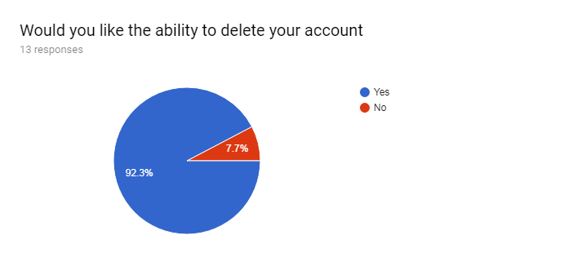

People really want the ability to delete their accounts so I will be adding this feature.

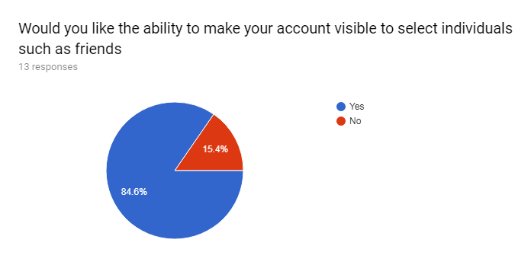

This feature was not implemented due to time constraints

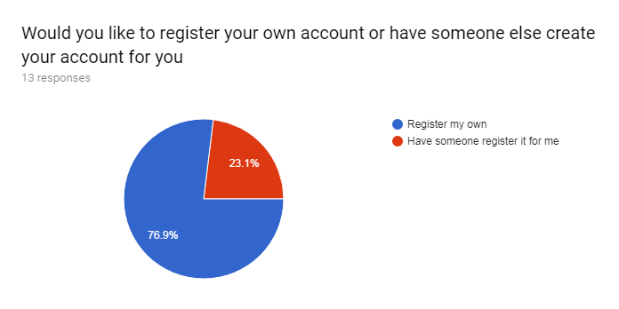

Most people want to the ability to register their own account so I will add this feature into my project.

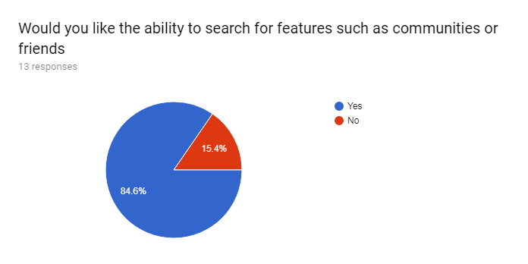

You are not able to search for friends or communities as these features were not implemented. However, you are able to search for other users and then go onto those user’s personal walls.

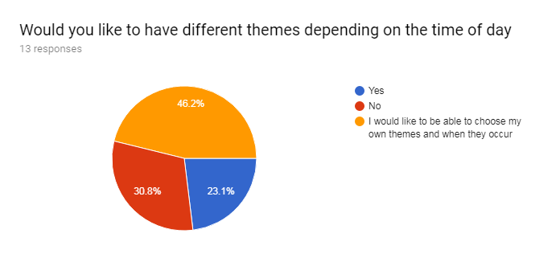

Themes was not included in the website due to the lack of time available to implement them in the end. This will please ~31% of users who took the poll though so not all is bad.

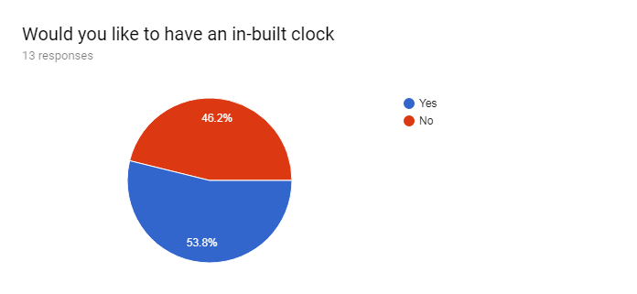

The inbuilt clock feature was omitted after input from a friend which said that there is already an inbuilt clock in the OS so why do you need an inbuilt clock in the website. This allowed me more time to focus on other features.

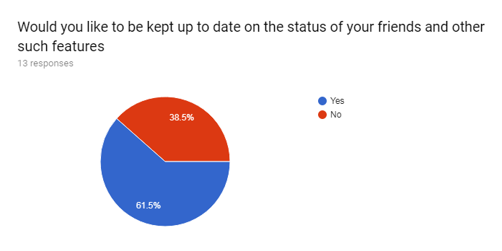

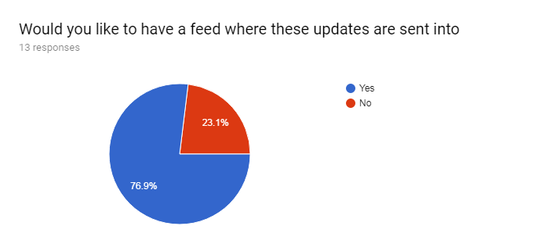People do want to be kept up to date on the status of their friends and other such features so I will create a feed which includes the post of others. However, as friends was not implemented the feed is now a super feed of sorts which displays the posts of all users who post on the site. This feed will be updated each time the page is refreshed.

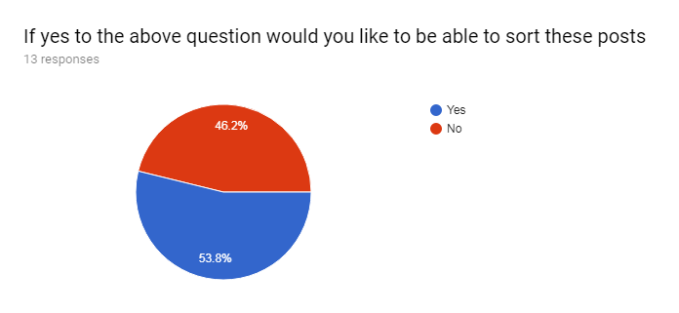

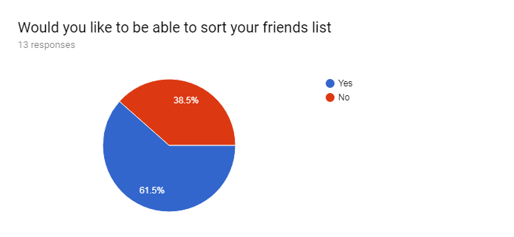

A majority of people would like to sort posts so I will include this as a feature. Surprisingly quite a few people also did not want to sort their feed so there will be a default sort that will only change when a user actively goes to change it.

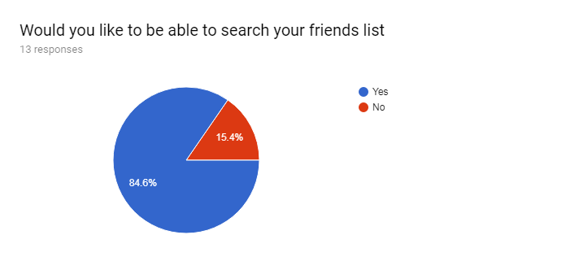

The friends list was not implemented as such you will not be able to search your friends list. The friends list was not implemented due to time constraints and the difficulty in its implementation. You are however able to search for other users.

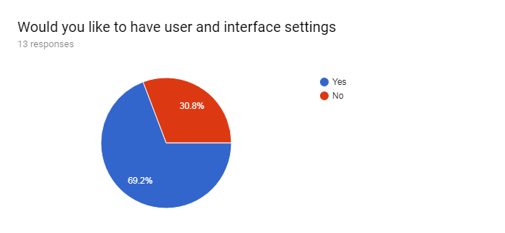

User settings were implemented but interface settings were not.

|  |
| --- |
| **Are there any features you would like to suggest?** |
| 7 responses |
| Even more bots. |
| Ignore all other parts of this vote. I wanted to suggest adding formatting (bold, italics, strike-through, underlined, etc), coloured text, and LaTeX to this. |
| No |
| You should be able to communicate to all the users on the network. This may be useful for notifying users of updates. Also, you should be able to moderate public posts and block users posting inappropriate content |
| A games page which links to games websites |
| No suggestions |
| maps to see where friends be- like snapmaps |

* One of these suggestions is a joke suggestion so I will ignore that one
* Two people have no suggestions
* One would like to include their own formatting for their page and Latex. Formatting is doable but I'm unsure about LaTeX. This unlikely to be added as I don’t really know how to go about making it. However it is interesting so I will look into it and give it an attempt if time allows.
* I believe that the 4th suggested feature is for admins. I don’t think I will have the time to give some users some rights while not giving others them. Again if time allows I will attempt this however it is unlikely to be implemented.
* A games page does indeed sound interesting but I will not be adding it as I believe it may take up a lot of time.
* Maps to see where friends are will not be implemented as there are quite a few things that I will have to deal with if it was an option. Such as the GDPR as I will be holding personal data of users. Or how I would be tracking users. Whether they consent to me holding their data etc.